KRR2

**Introduction to the course: AI & KRR**

* Intelligence & AI
* Reasoning and inference
* Challenges in AI & KRR
* Wrap-up
* This course

What is artificial intelligence?

Perform tasks commonly associated with intelligent beings. Intellectual processes characteristic of humans, reason discovery, meaning, generalize or learn from past experience.

The core is about making computers perform tasks that for us are quite easy and for them are not. Build solutions that work.

AI: addressing task hat we perform

Different abilities, compilations of different intelligence. Is multifaceted, several aspects that are interrelated.

1997: DeppBlue vs Kasparov at chess

2019: DeepMind’s AI beats a pro gamer on StarCraft II (strategic game)

Reinforcement learning: make some moves and get rewards.

Paper: *Reinforcement learning is enough (to explain intelligent behaviors)*

Humans can learn 1000x faster than computers, they use background knowledge

Experience is very important but also transmission. Language is an ability that distinguishes us from other species, very developed.

Inference: derive new informations from some informations we have

**Reasoning and inference:**

Inferences establishes a relation

Premises → conclusion

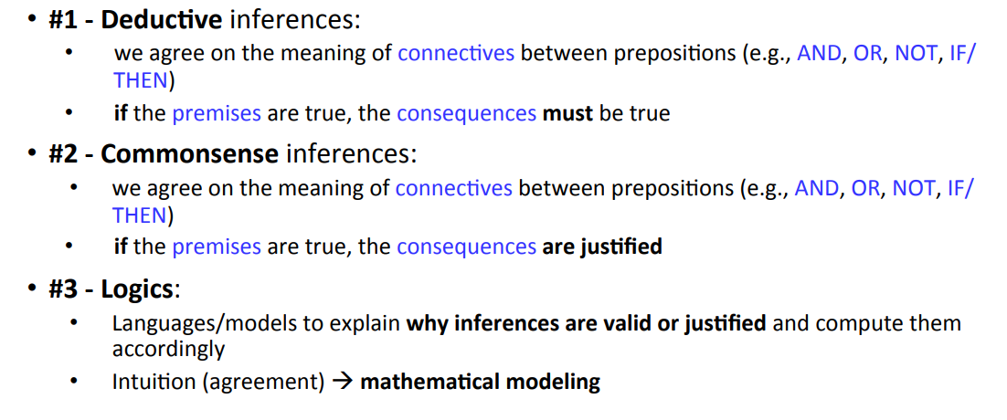

Deductive inferences: we have a mathematical theory than tells us when the conclusion is justified or not

**Challenges of AI**

* Humans learn faster and with limited training data”
* Different humans cognitive skills are highly connected and not learnt independently
* Humans can imagine and reasons about things and events that do not exist, and at higher level of depth and abstraction

Bad data means bad +completare

Build data infrastructure to support AI applications

GPT-3 language model, able to generate text in autoregressive factions?? Puréed asked on machine learning

Don’t: go-3 is reluctant to express something that id does not understand